Regional Addiction Resource Center
` Mini Grant June 1, 2025 - June 30, 2026

The New York City Regional Addiction Resource Center mini-grant provides funding for community-based events focusing on substance use awareness, engagement, and outreach across the five boroughs of New York City.

Grant Eligibility and Objectives
The New York City Regional Addiction Resource Center seeks to endorse prevention providers, treatment, and recovery organizations, and borough councils that meet the following criteria:
- Initiatives must focus on substance use outreach awareness, targeting vulnerable populations of the Bronx, Brooklyn, Manhattan, Queens, and Staten Island.
- Proposed projects must include data-based justifications to explain why the target population is considered vulnerable.
- Projects should aim to support and sustain community engagement, respect, and partnerships.
- Funding amounts will range from $500 to $2500.
- Applications are open to agencies and organizations operating within the five boroughs of New York City. Those organization should focus on culturally competent alcohol abuse, drug, and/or gambling prevention, support services, treatment, and recovery while promoting behavioral health and overall wellness.

Grant Restrictions
The Regional Addiction Resource Center will not provide funding for:
- Proposals that fail to include community outreach or partnership components.
- Projects lacking data to justify the designation of their target population as vulnerable.

If your community fits the criteria, please complete, and submit: Mini-Grant Application Form, Itemized Budget, Intended Media Strategies, and Final Report 30 Days AFTER EVENT. The New York City Regional Addiction Resource Center reviews all requests on a rolling application process. If accepted, it is required that your program send an invoice for the accepted supported amount and a complete W-9 form.

If there are any questions, please contact Debbie Wolff at dwolff@IUANY.org
Please send complete application to dwolff@IUANY.org

Mini Grant Application Form
(Please add additional sheets if necessary)

Community Event
Location
Organization
Address of Organization Requesting Funding
Federal Organization Number
Contact Name
Title
Phone
Email
Executive Official
Phone
Email

Proposed Event

Where will the community event take place?
Will it be a single event or recurring event?
Please list activities, programs and projects planned
Please list activities, programs and projects planned
Please list activities programs and projects planned
What is the expected number of participants?
Other:

Program Narrative
(Please use additional sheets if necessary)
Please provide a program narrative that justifies how the intended mini grant will support environmental prevention strategies. Emphasize its role in serving as a community outreach initiative for vulnerable

Cultural Competency Efforts
(Please use additional sheets if necessary)
Please outline specific strategies designed to promote cultural competency and foster inclusivity, ensuring they effectively address the diverse needs of New York City’s communities.

Risk Factors Addressed By Event
(Please use additional sheets if necessary)
The New York City RARC’s mini grant aims to strengthen protective factors through targeted community outreach events. These efforts will specifically address key environmental prevention risk factors the mini grant seeks to mitigate.

1.
2.
3.

Mini Grant Budget

Provide an itemized budget of expenses that you expect to incur in implementation of mini grant. The proposed budget should show exactly what requested dollars will purchase. Include expenses such as materials/supplies, equipment, and equipment rentals (maximum allowed 20%). All expenses must be specified in the ‘other’ category. Include total cost for the program and matching funds. Please be as specific as possible.

Itemized Budget
(Example)

Description of Item | Request | Explanation of Funds (Please be as specific as possible) | Total
Advertising/Marketing (Please be as specific as possible)
Equipment (Please be as specific as possible)
Food & Beverages (Please be as specific as possible)
Materials & Supplies (Please be specific as possible)
Other: (specify) (Please be as specific as possible)
Other: (specify) (Please be as specific as possible)

Media Campaign

A media campaign is a pre-requisite for the mini grant. Please apply both logos from InUnity Alliance and the NYC Regional Addiction Resource Center with your logo to support the campaign for community awareness and outreach with the date, time and place of the event, and other associated marketing campaign information. Examples in the past have been community posters, and palm cards. Please submit with application.

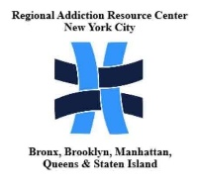
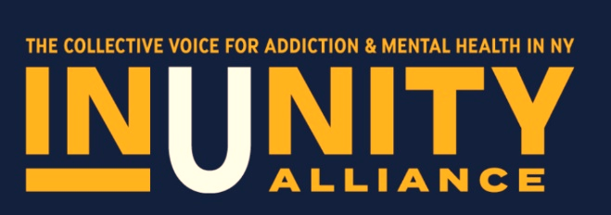

Mini Grant Application Signatures

Signature of Individual Certifying this Application:

Name (Print):
Title
Date

Signature of Executive Official:
Name (Print)
Title
Date

Final Report
Please email no later than 30 days after the event.
(Use additional sheets if necessary)
Email to dwolff@IUANY.org

Organization name

Event name

Event cost

Event start date

Event end date

Number of participants served by community event

Did you achieve the outcome as hoped?
Please describe.

**Please submit additional media images (photos) of the event.

Signature of Individual Certifying Final Report

Date

Signature of Organization Executive Certifying Final Report

Date

